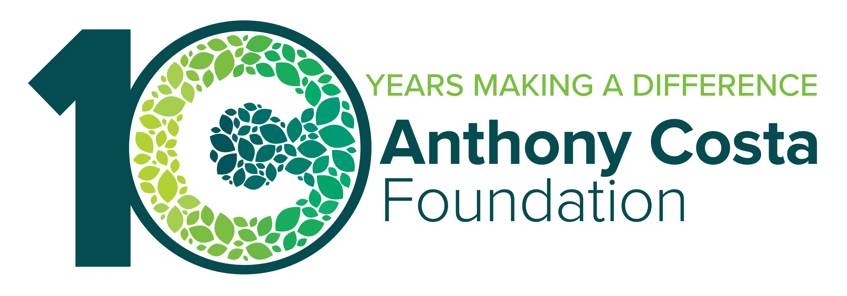
Strength in Community Grant Program
Organisational Capacity Building Grants – Expression of Interest

Organisation Details

- CEO contact details
- Application Contact contact details

Expression of Interest Summary
Provide a summary of your EOI in no more than 50 words.
Your summary should briefly describe: the key challenge or opportunity facing your organisation; the capability, capacity or organisational area you would like to strengthen; the difference this support could make for your organisation and the communities you serve e.g. "We are experiencing significant demand growth and need support to strengthen our operating model and workforce planning. Building these capabilities will help us improve service delivery, reduce organisational risk and better meet the needs of our community."

Which Anthony Costa Foundation Focus Area your organisation's mission and work most closely aligns with:
While your request may relate to more than one of the Foundation's Focus Areas, please select the ONE that best relates.
- Thriving Children and Young People
- A Safe Place to Live
- Creating Vibrant Communities

You can read more about or focus areas here:https://www.costaam.com.au/partnersfoundation/guidelines-eligibility/

Which geographic areas does your organisation support? Please select all that apply.
- City of Greater Geelong
- Surf Coast Shire
- Borough of Queenscliffe
- Golden Plains Shire
- Colac Otway Shire
- Other
The Foundation's geographic focus is the Geelong/G21 region of Victoria. We recognise that some organisations support communities within Geelong/G21 as well as across a broader geographic area. If this applies to your organisation, please select the relevant Geelong/G21 locations and choose "Other" to tell us about any additional areas you support.

Expression of Interest
This EOI is designed to help us understand what you learned from the Springboard diagnostic, the organisational capability you most want to strengthen, and your readiness to undertake this work. You do not need to identify a specific consultant, develop a detailed scope of work or provide a budget at this stage. If selected, Benefolk will work with your organisation to further define the support required.
- What were the most important insights or findings from your diagnostic results? (maximum 250 words)
Please reflect on the findings that were most meaningful or surprising for your organisation. Consider the strengths, challenges, gaps or opportunities highlighted by the diagnostic, and explain why these insights are important for your organisation's future. We are interested in your interpretation of the results, not simply a summary of the scores. For example: What surprised you? What was confirmed? What are the most important areas
for improvement? What opportunities emerged from the results?

- Which one or two organisational effectiveness areas do you most want to strengthen over the next 2-3 years?
Please select up to two areas that are the highest priorities for your organisation to strengthen over the next 2–3 years. Use your Springboard diagnostic findings to help identify where additional capability or support could make the greatest difference.
- Strategy & Governance - Clarity where the organisation is going, what matters most, and how it makes decisions
- Leadership & Culture - Strong leadership, aligned teams, and a capable, resilient workforce
- Growth & Sustainability - Strong financial sustainability and the ability to convert opportunity into consistent, diversified income
- Operating Model & Delivery - Delivers programs and services effectively and consistently, with strong modern structure, systems and processes
- Positioning & Influence - Clearly understood, trusted, and able to influence key audiences and systems
- Risk & Stability - Stable under pressure and capable at managing risk and uncertainty
- Transformation & Renewal - Ability to transform and renew when needed, across strategy, structure, capability or model
- Performance, Data & Insight - Measure what matters, improve performance and make better decisions with confidence

- Describe the key challenge or opportunity your organisation is facing that stronger organisational capability could help address. (maximum 400 words)
Please describe the key organisational challenge or opportunity you would most like to address through this program. Consider what is happening within or around your organisation, why it matters, and how strengthening your organisation’s capability in this area could make a difference. Focus on the challenge or opportunity rather than the specific solution or support you think you need.

- Please attach the relevant summary page(s) from your Springboard diagnostic results that relate to and help demonstrate the challenge or opportunity described in Question 3. If your response draws on more than one area of the diagnostic, please attach all relevant summary pages.
Maximum file size is 10MB. If a document you wish to upload is larger than 10 MB please email it to foundation@costaam.com.au.

- If your organisation successfully addressed this challenge or opportunity, what difference would it make for: your organisation, the people or communities you serve, and your longer-term sustainability. (maximum 350 words)
Please describe the difference addressing this challenge or opportunity could make. Consider the benefits for your organisation, the people or communities you serve, and your organisation’s longer-term sustainability. Focus on the changes or improvements you hope to see, rather than the activities you would undertake.

- How ready is your organisation to undertake this work, and when would be the right time to begin?
Building and embedding new organisational capabilities takes time. Support through this program would take place during 2027 and/or 2028 and require committed team members to work with Benefolk specialists throughout the process. Please tell us which year would best suit your organisation and why, including any factors that influence your readiness and capacity to engage in the work.
- 2027
- 2028
- Either 2027 or 2028
Please explain your selection and your organisation's readiness and capacity to undertake the work. (maximum 150 words)

- Who from your organisation would commit to participating in and championing this work and what role would they play? (maximum 150 words)
Please provide the name and position of the key people who would be involved, along with a brief description of the role each person would play.

- What commitment is there from your Board and leadership team to support this work and act on what emerges? (maximum 150 words)
Please describe how your Board and leadership team support the organisation undertaking this work. Consider how the work aligns with organisational priorities, their willingness to provide the necessary time and resources, and their commitment to considering and acting on what emerges from the process.

- How would your organisation be most willing to contribute to shared learning with other participants and the broader community sector?
Shared learning is an important part of this program. Please select up to three activities your organisation would be most willing and able to contribute to.
- Participate in peer learning sessions
- Participate in evaluation activities
- Share lessons learned with other organisations
- Contribute to a case study or story of change
- Present at a future learning event
- Other

Declarations
I declare that the information in this submission and any attachments is true and correct at the
time of submission and I am authorised to submit the application on behalf of the organisation.
- Yes
- No

I understand that the Anthony Costa Foundation may on occasion forward and/or discuss my
submission with external reviewers for the purpose of assessment and/or other trusts and
foundations for the purpose of consideration.
- Yes
- No

